CWWS Fund
Project Name:  Water Plant Expansion | Department:  Public Works - Utilities
Type of Project:  Addition of Capacity | Contact:  Chuck Soules
Total Project Cost:
$24,600,000

Description:
The proposed water treatment plant improvements will keep the 2.5 million gallons per day (MGD) plant operating and improve plant efficiencies. Highlighted items for this improvement include, remove and land apply lagoon residuals, rehab/paint primary and secondary basins, replace filter valve pneumatic actuator, and replace volumetric feeder.
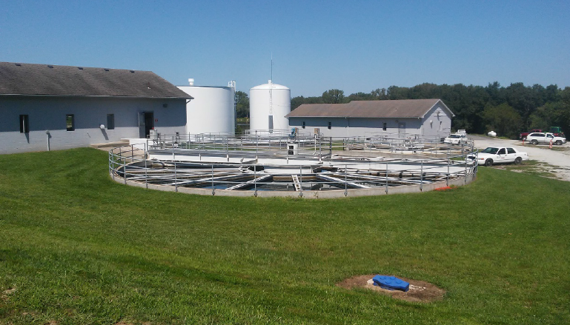
Justification:
This project is necessary to maintain the production capacity and meet state drinking water standards.

Impact on Operating Costs
There will be ongoing operating costs for the Water Plant. These improvements will being to set the stage for the future Water Plant expansion.

Planned Expenditures
 | FY2027 | FY2028 | FY2029 | FY2030 | Total
Engineering | $2,100,000 | - | - | - | $2,100,000
Construction | - | - | $7,500,000 | $15,000,000 | $22,500,000
Total | $2,100,000 | - | $7,500,000 | $15,000,000 | $24,600,000

Funding Sources
 | FY2027 | FY2028 | FY2029 | FY2030 | Total
CWWS | $2,100,000 | - | $7,500,000 | $15,000,000 | $24,600,000
Total | $2,100,000 | - | $7,500,000 | $15,000,000 | $24,600,000

